UNITED STATES

SECURITIES AND EXCHANGE COMMISSION

Washington, D.C. 20549

SCHEDULE 14A INFORMATION

Proxy Statement Pursuant to Section 14(a) of

the Securities Exchange Act of 1934
(Amendment No. )

Filed by the Registrant ☒

Filed by a Party other than the Registrant ☐

Check the appropriate box:

- Preliminary Proxy Statement

- Confidential, for Use of the Commission Only (as permitted by Rule 14a-6(e)(2))

- Definitive Proxy Statement

- Definitive Additional Materials

- Soliciting Material under § 240.14a-12

MONTAUK RENEWABLES, INC.

(Name of Registrant as Specified In Its Charter)

N/A

(Name of Person(s) Filing Proxy Statement, if Other Than the Registrant)

Payment of Filing Fee (Check all boxes that apply):

- No fee required.

- Fee paid previously with preliminary materials.

- Fee computed on table in exhibit required by Item 25(b) per Exchange Act Rules 14a-6(i)(1) and 0-11.



Your Vote Counts!

MONTAUK RENEWABLES, INC.

2026 Annual Meeting
Annual Meeting Date: May 26, 2026
Time: 9:00 a.m., Eastern Daylight Time
Location: www.virtualshareholdermeeting.com/MNTK2026
Vote by May 25, 2026
11:59 PM Eastern Daylight Time
MONTAUK RENEWABLES, INC.
5313 CAMPBELLS RUN ROAD, SUITE 200
PITTSBURGH, PA 15205



V91958-P46019





You invested in MONTAUK RENEWABLES, INC. and it’s time to vote!

Important Notice Regarding the Availability of Proxy Materials for the Stockholder Meeting To Be Held on May 26, 2026.
You have the right to vote on proposals being presented at the Annual Meeting.

Get informed before you vote

View the Notice and Proxy Statement and Annual Report on Form 10-K for the fiscal year ended December 31, 2025 online at www.ProxyVote.com OR you can receive a free paper or e-mail copy of the material(s) by requesting prior to May 12, 2026. If you would like to request a copy of the material(s) for this and/or future stockholder meetings, at no charge, you may (1) visit www.ProxyVote.com,

- call 1-800-579-1639 or (3) send an email to sendmaterial@proxyvote.com. You will not otherwise receive a paper or e-mail copy. If sending an email, please include your control number (indicated below) in the subject line. Unless requested, you will not otherwise receive a paper copy or email copy. Requests, instructions and other inquiries sent to this e-mail address will NOT be forwarded to your investment advisor.

We encourage you to access and review all of the important information contained in the proxy materials before voting.
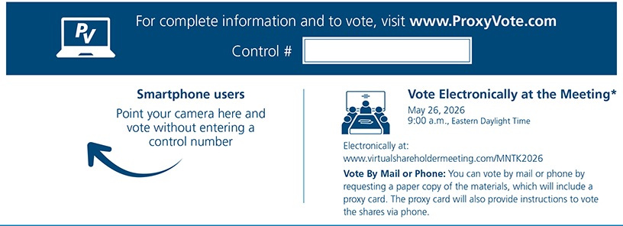

* Please check the meeting materials for any special requirements for meeting attendance.

Vote at www.ProxyVote.com

THIS IS NOT A VOTABLE BALLOT

You cannot use this notice to vote the shares. This communication

presents only an overview of the more complete proxy materials
that are available to you on the internet or by mail. You may view
the proxy materials online at www.proxyvote.com or easily request a
paper copy (see the reverse side). We encourage you to access
and review all of the important information contained in the proxy
materials before voting.

 |  | Board
Voting Items |  | Recommends
1. | Election of two nominees to the Board of Directors to serve as Class III directors for a three-year term expiring at
 | the 2029 Annual Meeting of Stockholders.
1a. | Jennifer Cunningham | For
1b. | Sean F. McClain | For
2. | Ratification of the appointment of Grant Thornton LLP as the independent registered public accounting firm for the | For
 | fiscal year ending December 31, 2026. | For


Prefer to receive an email instead? While voting on www.ProxyVote.com, be sure to click “Delivery Settings”.

V91959-P46019

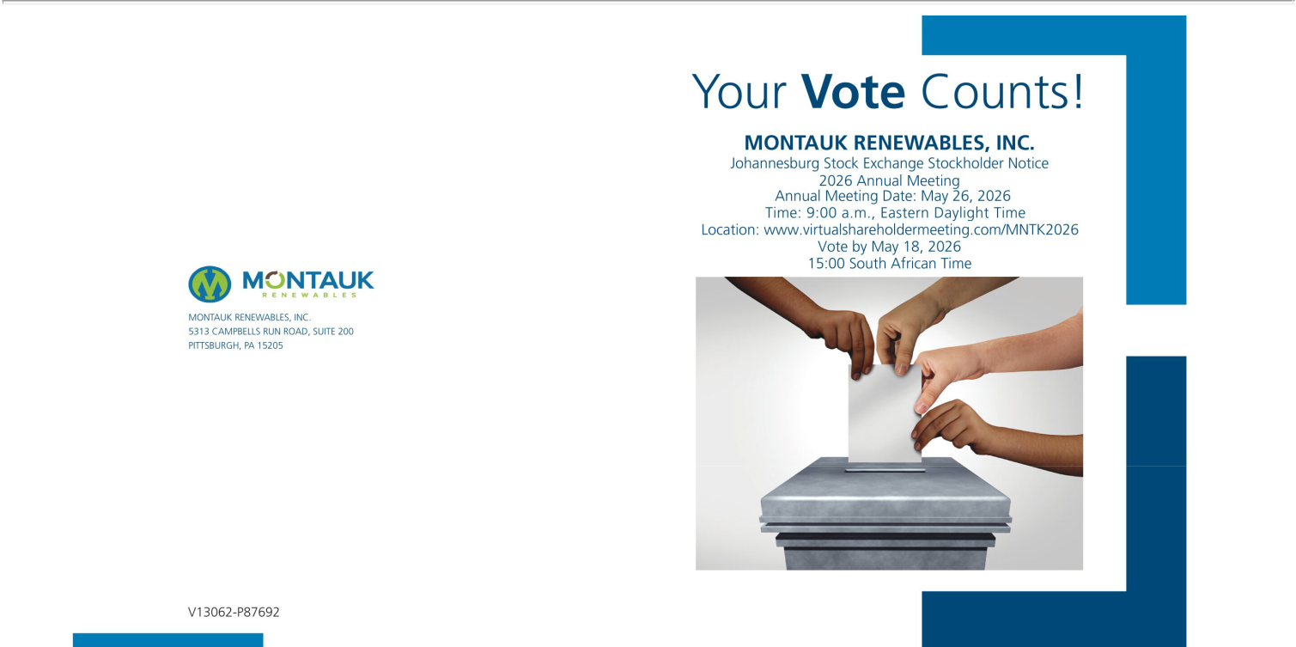

You invested in MONTAUK RENEWABLES, INC. and it’s time to vote!

Important Notice Regarding the Availability of Proxy Materials for the Stockholder Meeting To Be Held on May 26, 2026.

You have the right to vote on proposals being presented at the Annual Meeting. Stockholders registered on the South African section of the Company’s register of stockholders may attend and vote electronically during the Annual Meeting. We strongly encourage you to vote prior to the Annual Meeting and no later than 15:00 South African Time on May 18, 2026. Information regarding how stockholders may vote prior to and at the Annual Meeting is described below. Further, stockholders are not permitted to transfer their shares to the United States register any time following the end of trading in South Africa on May 18, 2026 and until the conclusion of the Annual Meeting on May 26, 2026.

Get informed before you vote

You are receiving this notice because you are a stockholder registered on the South African section of the Company’s register of stockholders. The proxy materials, including the Proxy Statement and Annual Report on Form 10-K, are available at www.materials.proxyvote.com/61218C or you may request a paper or email copy of the full set of the proxy materials, at no charge, for this Annual Meeting and future stockholder meetings by, in the case of shares held in the Strate System, contacting your Central Securities Depositary Participant or broker, as applicable, and. if you are a stockholder of record, facsimile transmission at +27 (0)11 688 5238, e-mail at proxy@computershare.co.za or mail at Computershare Investor Services Proprietary Limited, Rosebank Towers, 15 Biermann Avenue, Rosebank, 2196 (Private Bag X9000, Saxonwold, 2132) South Africa, in each case, no later than May 18, 2026.

We encourage you to access and review all of the important information contained in the proxy materials before voting.

Attend the Annual Meeting Vote Prior to or Electronically During the Annual Meeting

If you wish to attend the Annual Meeting, you will need a control number to attend and/or vote your shares. Directions on how to obtain a control number are described in the proxy materials.

Instructions on how to vote your shares are included in the proxy materials.

THIS IS NOT A VOTABLE BALLOT

You cannot use this notice to vote your shares. This communication presents only

an overview of the more complete proxy materials that are available to you on the
internet or by mail. You may view the proxy materials online at
www.materials.proxyvote.com/61218C or easily request a paper copy (see the
reverse side). We encourage you to access and review all of the important

information contained in the proxy materials before voting.

Boa

Voting Items Recom 1. Proposal to elect two nominees to the Board of Directors for a term expiring at the 2029 Annual Meeting of Stockholders.


 | Nominees:
1a. | Jennifer Cunningham | For
1b. | Sean F. McClain | For
2. | Ratification of the appointment of Grant Thornton LLP as independent registered public accounting firm for the fiscal year ending December 31, 2026. | For

